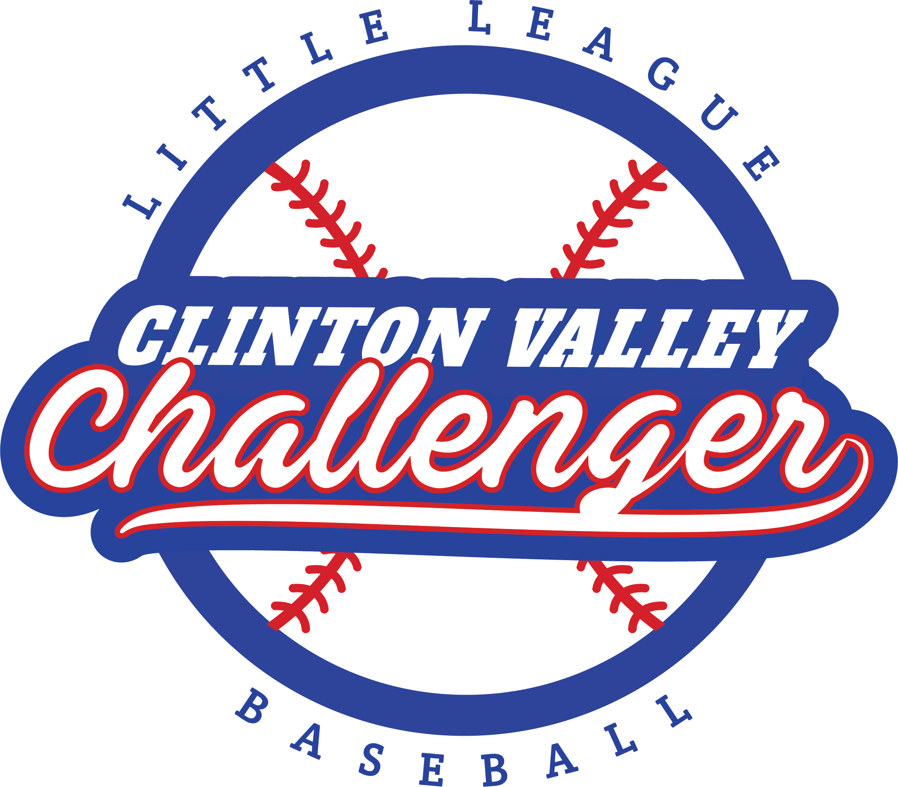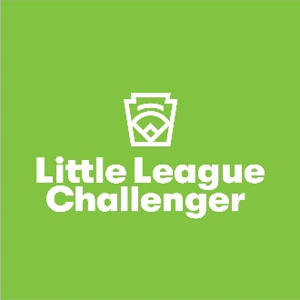

Clinton Valley Little League

**Challenger Baseball**

**New Senior Field Project**

**Sponsorship Level Program**

* ***Single Hit Level:*** $1,000 donation includes a 3 x 6-foot banner with your logo/company name to be displayed on the outfield fence for one baseball season! (May-October)
* ***Double Hit Level:*** $2,000 donation includes a 3 x 6-foot banner with your logo/company name to be displayed on the outfield fence for two baseball seasons! (May-October)
* ***Triple Hit Level:*** $3,000 donation includes a 3 x 6-foot banner with your logo/company name to be displayed on the outfield fence for three baseball seasons! (May-October)
* ***Home Run Level:*** $5,000 or more donation includes a 3 x 6-foot banner with your logo/company name to be displayed on the outfield fence for six baseball seasons! (May-October)

*Monies raised by your donation banner will get us one step closer to building a Little League adaptive field for our Senior League players in Neil Reid Park.*

We are a 501c3 non-profit organization

To reserve your banner, please contact Marilyn @ mwitt26@msn.com