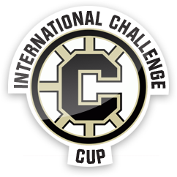
Looking for "Team Ambassadors" for the Chilliwack International Bantam Challenge Cup
Qualifications:
- Must be available all weekend from October 5-9, 2017 during your assigned teams games
- Must be either a 1st or 2nd year Atom or PeeWee aged minor hockey player
- Game schedule for your team that you are will be provided a week prior to event, you will be required to be there half an hour prior to game start time and stay with your team until after the game.
- Able to help your assigned team with such things as; sticks, water bottles, motivation, and anything else that they may require during these days
This experience provides our young players the opportunity to meet players from various locations while watching some exceptional hockey.

Please use this link to apply online:
http://www.cmhachallengecup.com/volunteer

Please email any inquiries to chwk.bantamaaa.challenge.cup@gmail.com
Our selection committee will advise you further details in September.

