2016 MATS FOOTBALL COMMUNICATION
via
Miramonte Boosters Club Website/ Football Pages
Sport Ngin Account & Mobile App

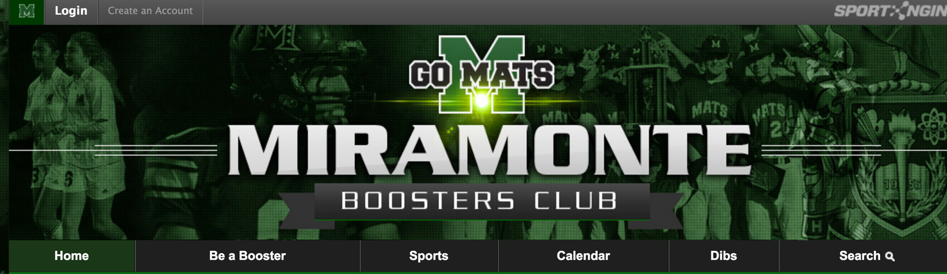
To ALL Football Players and Parents (Varsity, JV & Frosh): MATS Football is excited to start using
the Boosters Website and the Sport Ngin Mobile App for transmitting Team updates this year!

To receive future Mats Football Team emails and/or texts generated from the Miramonte Boosters website “Join the Team”: Check your inbox for an email recently sent to you from “no reply@ Sport Ngin.com” (Mats Football - Miramonte Boosters Club).
Then complete the following 10 steps:

1) “Accept Invite”(green button). This allows you to create your own Sport Ngin Account (host of the Boosters/Football website).

2) Account Login: enter password if already an Account holder OR Create new Account.

3) On the Dashboard, click “Accept” (black button). Then you will Login. (see sample Dashboard below)

4) At “Select a Profile” screen: Click your name if account already set up OR Create a new profile.

5) On Dashboard (click Login box at top, left side of screen) go to “My Profile” and verify info.
Under the “Team Membership” section, the Mats Football team you have joined will now be listed.

Most Critical Steps:

6) Go to “Account Settings” (bottom of dashboard menu) to verify info or change or add:
name, password, email address or mobile phone#.

7) Make sure your “Mobile Phone Number” is entered (to get Team texts) and check box described in #9.

8) If new phone entry, Click “Send Validation Code” button on right side. This will be sent to you via text. Then, enter the Validation Code in field.

9) Review the “Notification Settings” section.
Check 2 boxes in the Miramonte Boosters Club section: “email” box AND “Text (your cell #)” box

You’re all set for future Team texts and emails…

10) now set up the Sport Ngin Mobile App (iOS and Android and Apple products)

Varsity Team ID: 227947….JV Team ID: 227948….Frosh Team ID: 227949

Questions? Contact Varsity Team Parent, Sandra McGonigle 4mcgons@gmail.com 925-360-6077

Sample: Dashboard menu (Boosters site)

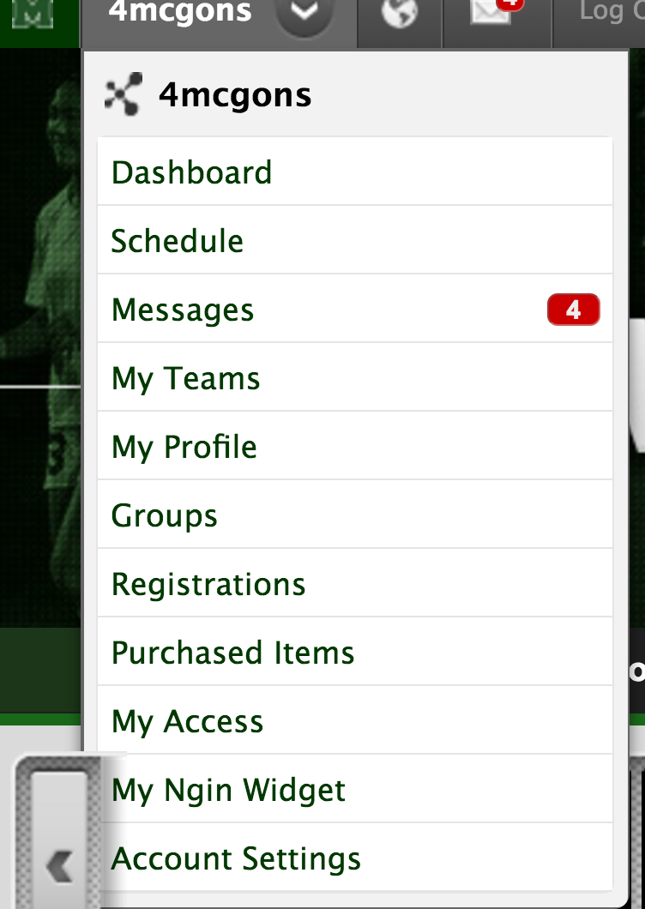

Sample: Account Settings & Notification Settings

