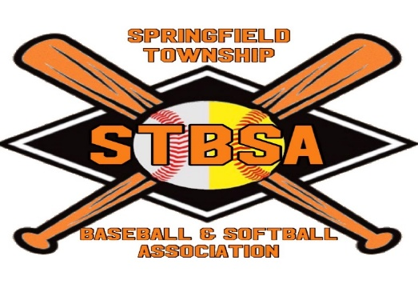

STBSA.TEAMPAGES.COM
Spring 2022 Baseball/Softball Registration
STBSA’s Registration will open December 13, 2021
Go online at www.stbsa.teampages.com
For Boys (4-14 years old) and Girls (4-14 years old)
STBSA has once again partnered with Active to assist us in automating our Registration process!
Complete your registration online by January 16, 2022 and receive a $10.00 early registration discount! Also, receive a $10.00 discount for multiple children registered.
No Increase to Rates for 2022
Ages 4-6 $80.00 ($60 registration + $20 for lottery fundraiser*/**)
Ages 7-8 $105.00 ($85 registration + $20 for lottery fundraiser*)
Ages 9-10 $115.00 ($95 registration + $20 for lottery fundraiser*)
Ages 11-12 $125.00 ($105 registration + $20 for lottery fundraiser*)
Ages 13-14 $135.00 ($115 registration + $20 for lottery fundraiser*)
*To streamline our lottery fundraiser, we have included $20 in the registration fees. If you have multiple children registered, the fundraiser fee will only apply to the first two registrations.
**League ages are determined for Boys as of April 30, 2022. Girl’s ages will be determined as of December 31, 2022. All new players must provide proof of age.
*** If you have any questions please contact any board member listed on our website

Tryouts will be in February for all 7-10 year old players and/or if you would like your son/daughter to be evaluated to play an age group above their actual age.
*Credit Cards are accepted with online registration at www.stbsa.teampages.com. STBSA is an all-volunteer organization. All league families commit to volunteer in the concession stand, assist in work days, participate in fundraising efforts, and support and respect coaches, umpires, and league officials. We continually ask for support from all STBSA members. Please contact us if you are interested in joining the board, coaching, joining the concession stand committee, etc.

