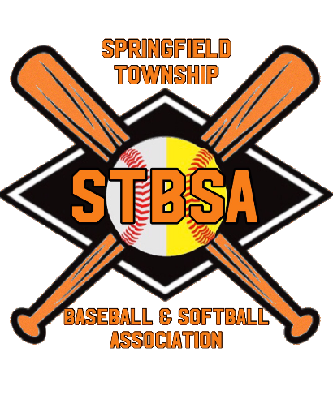

FALL 2021 BASEBALL/SOFTBALL REGISTRATION OPENS JUNE 1ST
STBSA’s preferred method of Registration is
Online at STBSA.TEAMPAGES.COM
For Boys (4-12 years old) and Girls (4-12 years old)
We are pleased to announce that STBA has once again partnered with Active to assist us in automating our Registration process!
** DEADLINE TO REGISTER IS JULY 15TH, 2021 **

Registration Fee is $65 per player (late fee of $25 for players registered after deadline, no exceptions!)
AGE GROUPS BEING OFFERED:
TBALL 4-6, COACH PITCH 8U, KID PITCH 10U AND 12U

THERE WILL NOT BE AN IN-PERSON SIGN-UP. IF YOU NEED A REGISTRATION FORM AND CANNOT ACCESS THE ONLINE PROCESS PLEASE CALL MARTIN RAKOFF 234-855-5550.

Players will be evaluated to either play in the age group they participated in during this Spring or where they will play next Spring based on age. Dom Larocca, VP of Baseball and Ashley Phillis, VP of Softball will review these decisions and assist in finding the proper age group. Season will run from August 16 to September 24 for Softball. Season will run from August 15 to October 10th for Baseball. All volunteers should indicate what you would like to assist with when you register online. Once registration is closed all Managers will be notified of your assistants and be provided additional information regarding the season.

